**Project on flights:**

**Step:1:** Install seaborn.

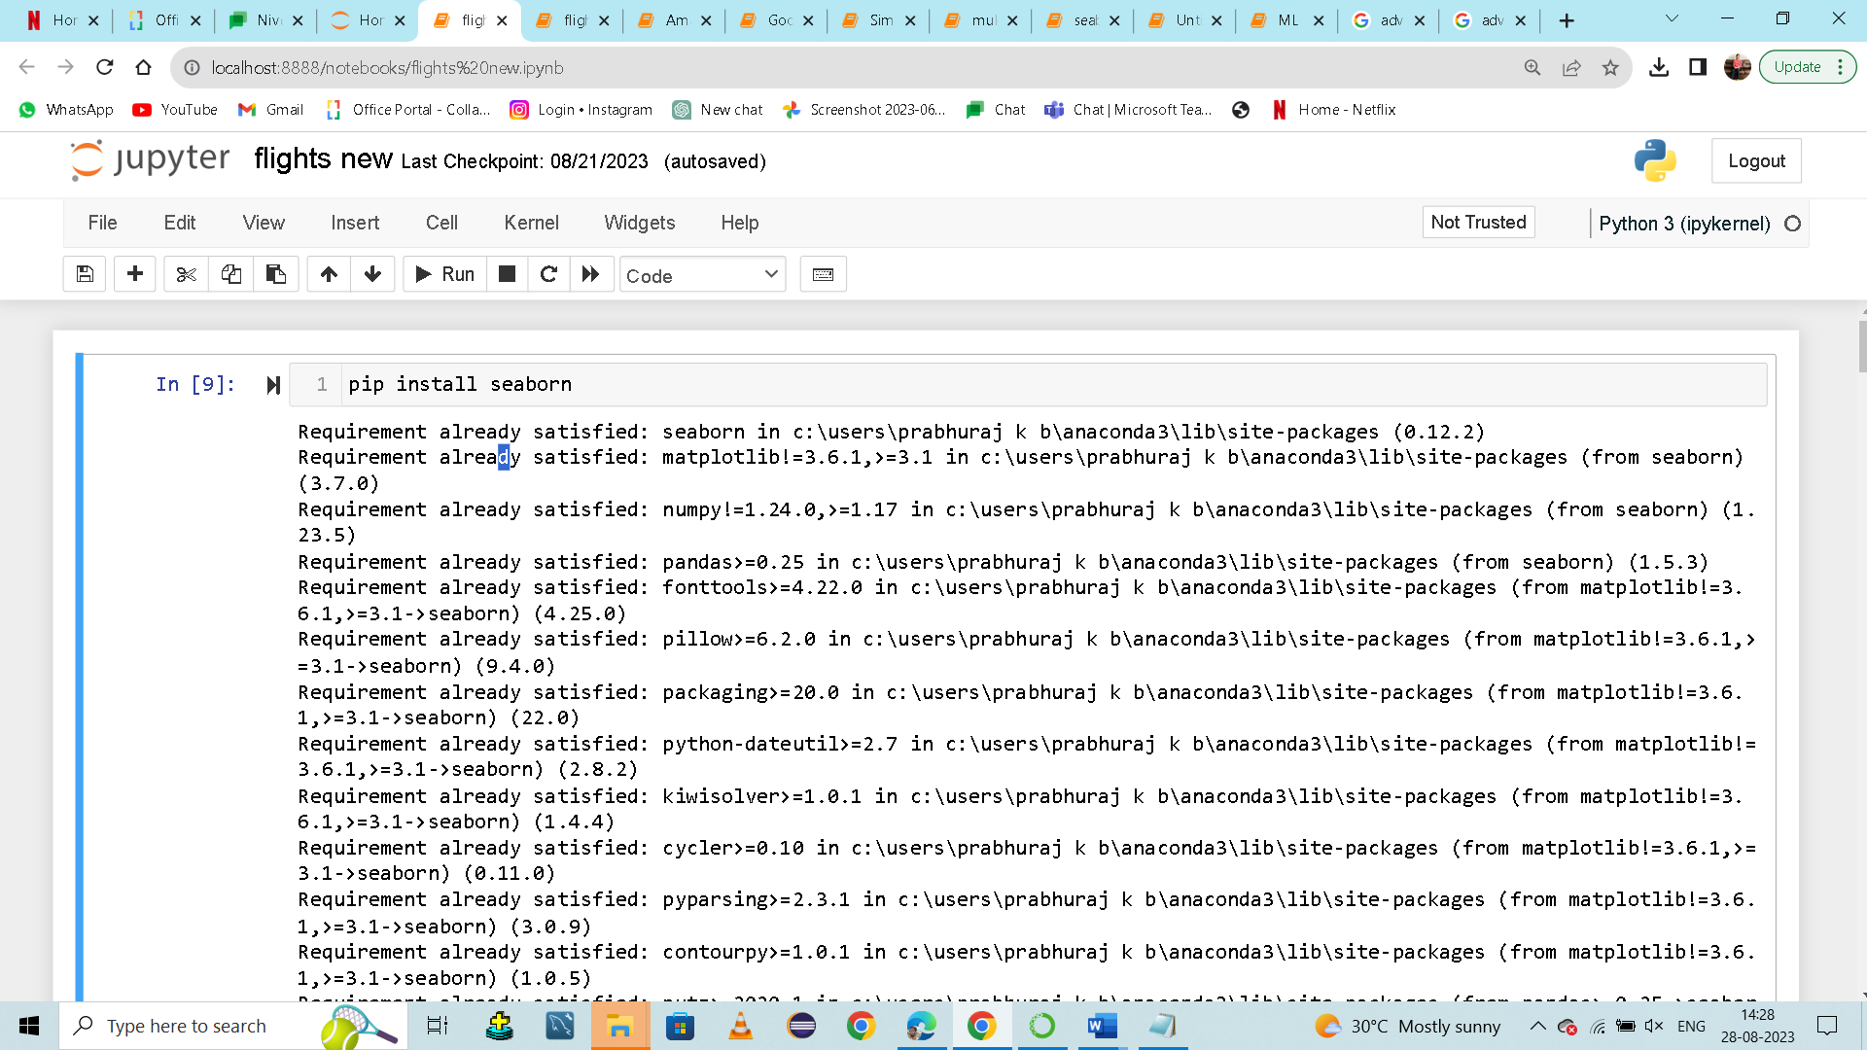

**Step:2:** import matplotlib. pyplot as plt.

import seaborn as sns.

import warnings.

warnings.filterwarnings("ignore").

import pandas as pd.

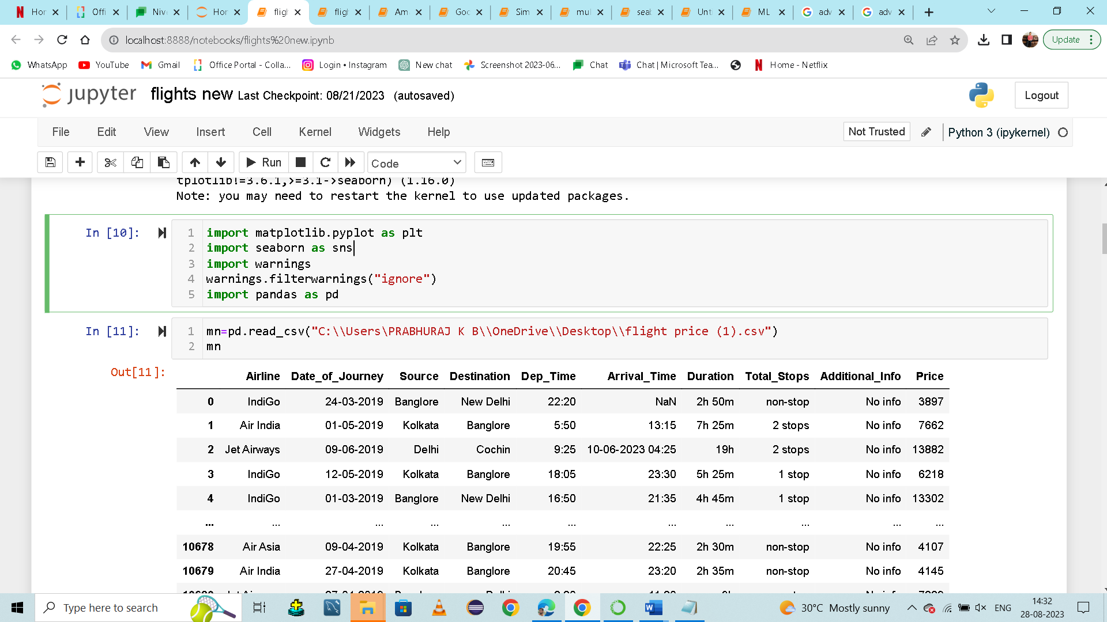

**Step:3**: Assigning Data Frame name as mn and taking previously imported pandas as pd.read_csv. Within parentheses in double coad extracting csv file.

**Step:4**: Check the information about DataFrame with Total columns & Total Rows. The info() method is used to prints information about 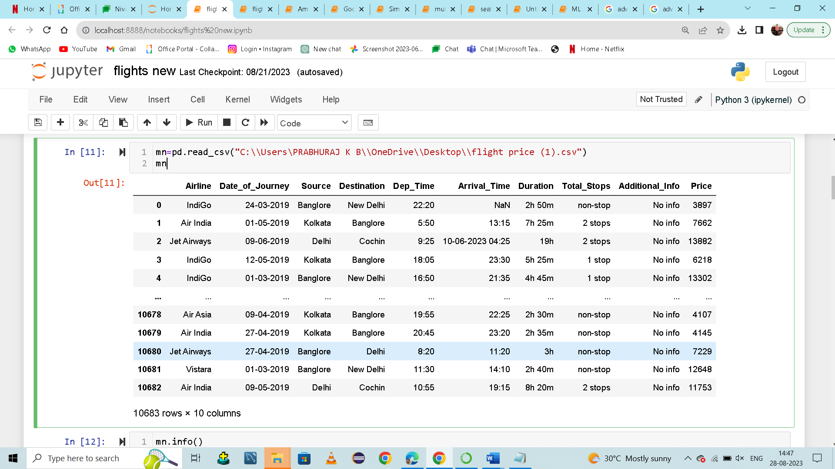the DataFrame. The information contains the number of columns, column labels, column data types, memory usage, range index, and the number of cells in each column (non-null values).

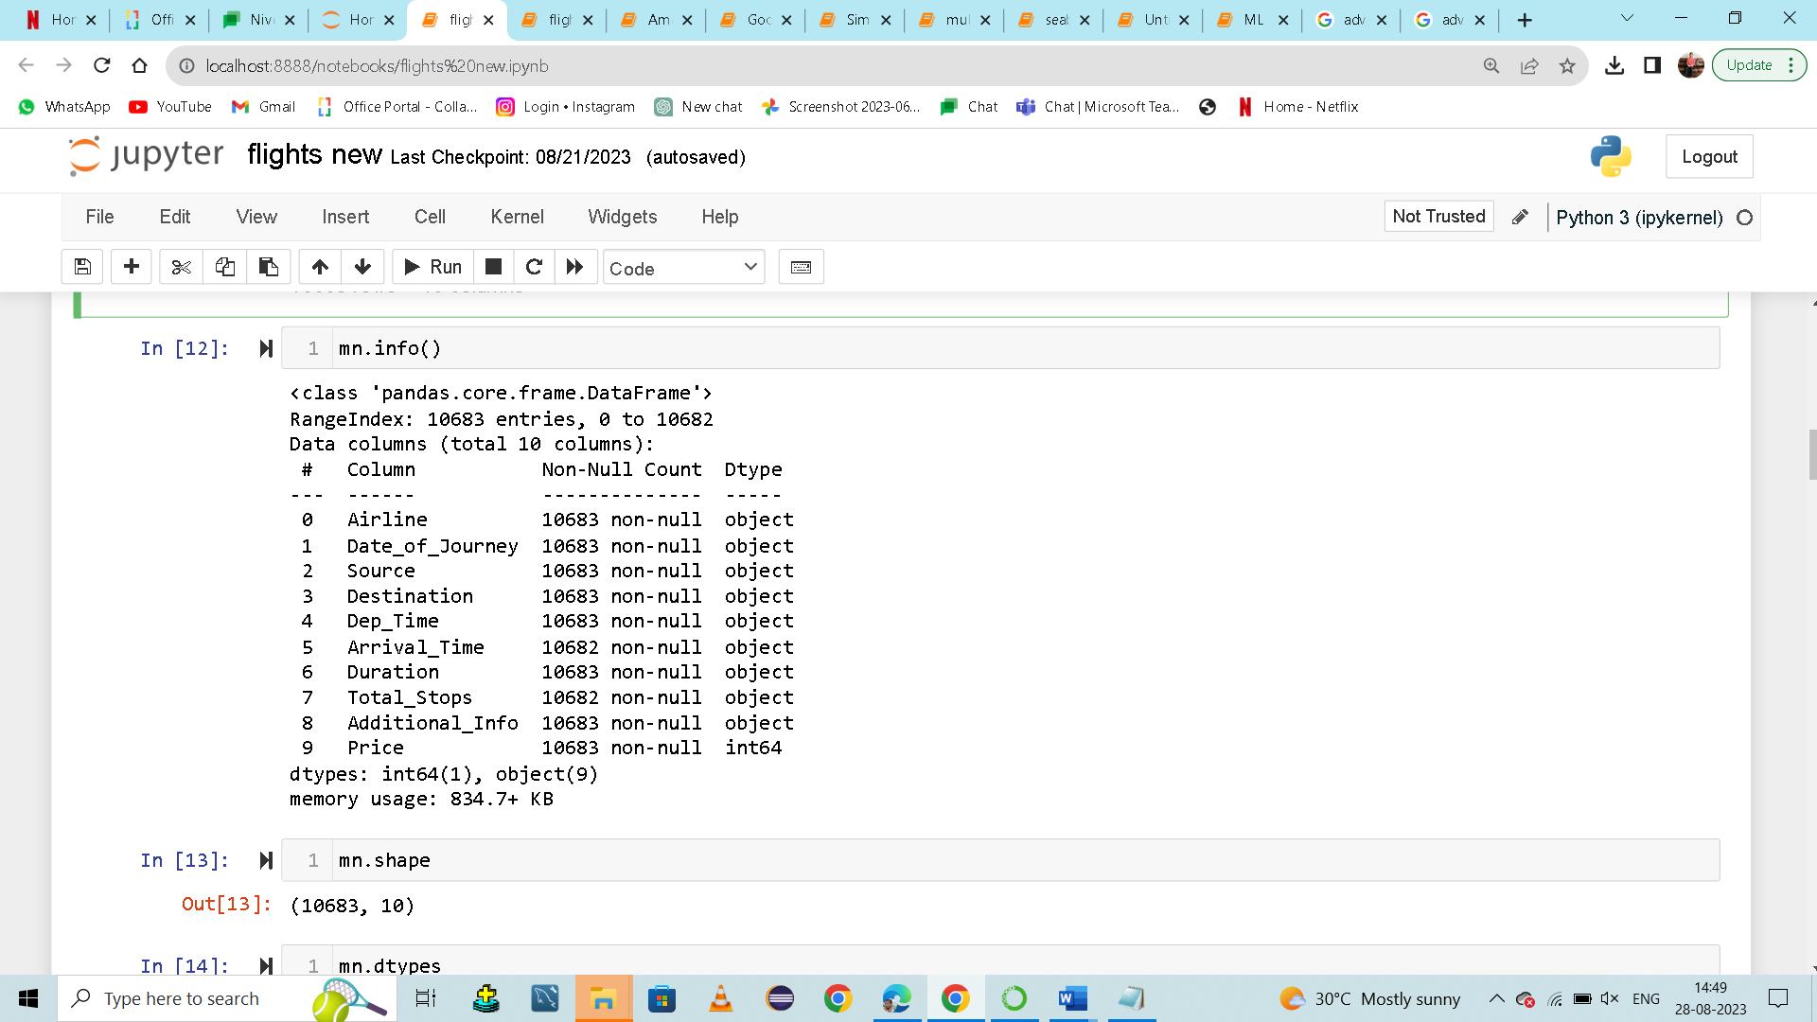

**Step:5**:

checking the shape. mn is predefined variable. shape() is used to find the dimensions of data structures, such as NumPy arrays and Pandas DataFrames

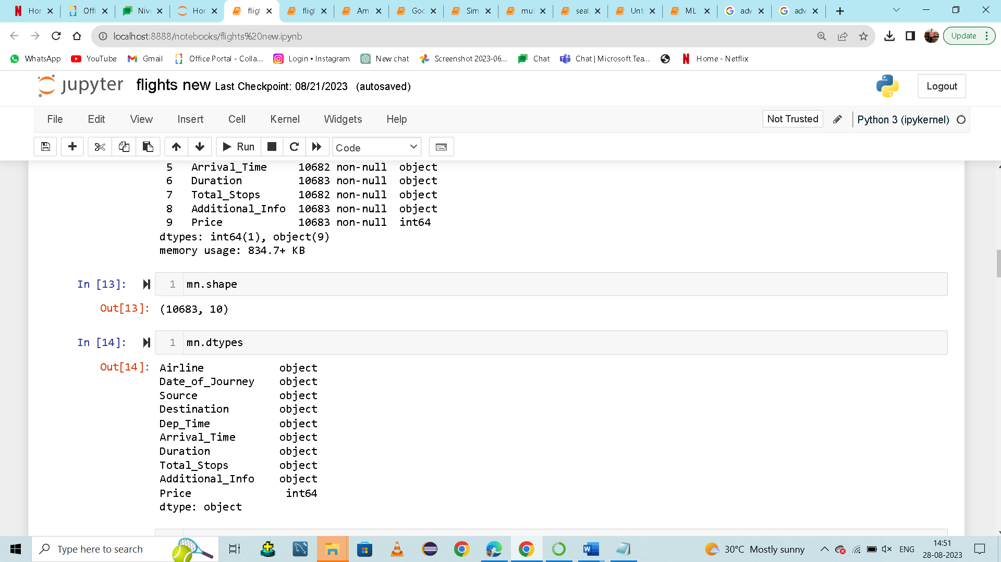

**Step:5**:

checking the type. mn is predefined variable type() is a built-in function that is used to return the type of data stored in the objects or variables in the program.  used to return the type of data stored in the objects or variables



**Step:6**:

checking the size. size() function count items from a given array and give output in the form of a number as size.and mn is predefined variable

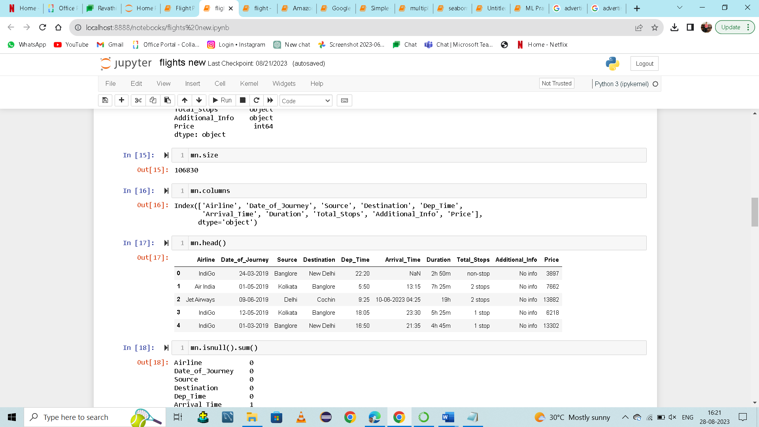

**Step:7**:

checking the columns.  a vertical arrangement of items printed or written on a page.to fetch all column names present in the data frame we use column function.by giving predefined variable mn.

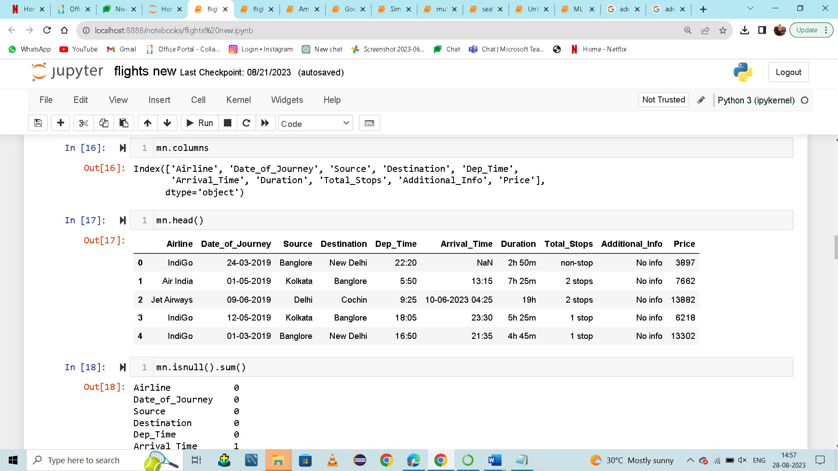

**Step:8**:

Fleshing top 5 values we use head.we are giving predefined variable mn.head()it will give use top five values present in the dataframe and if we need more than five top values in parathesis have to give in number inside ().



**Step:9**:

mn is predefined variable. Isnull().sum() is used to returns the number of missing values in the dataset.Rechecking the null value in sum method.

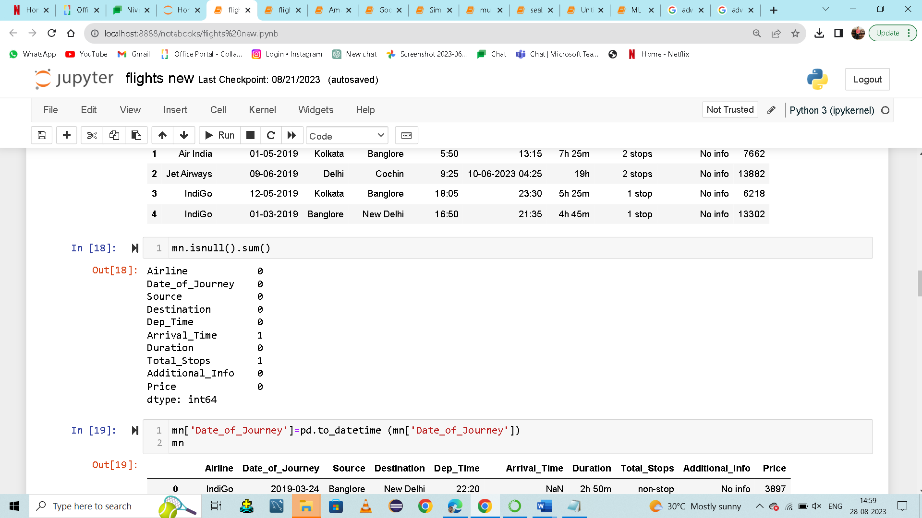

**Step:10**:

Converting the columns into data time.mn is a predefined variable.then in square bracket we are fletching column name called 'Date_of_Journey' in double code.by using datetime function we are converting 'Date_of_Journey' in the form of datetime.

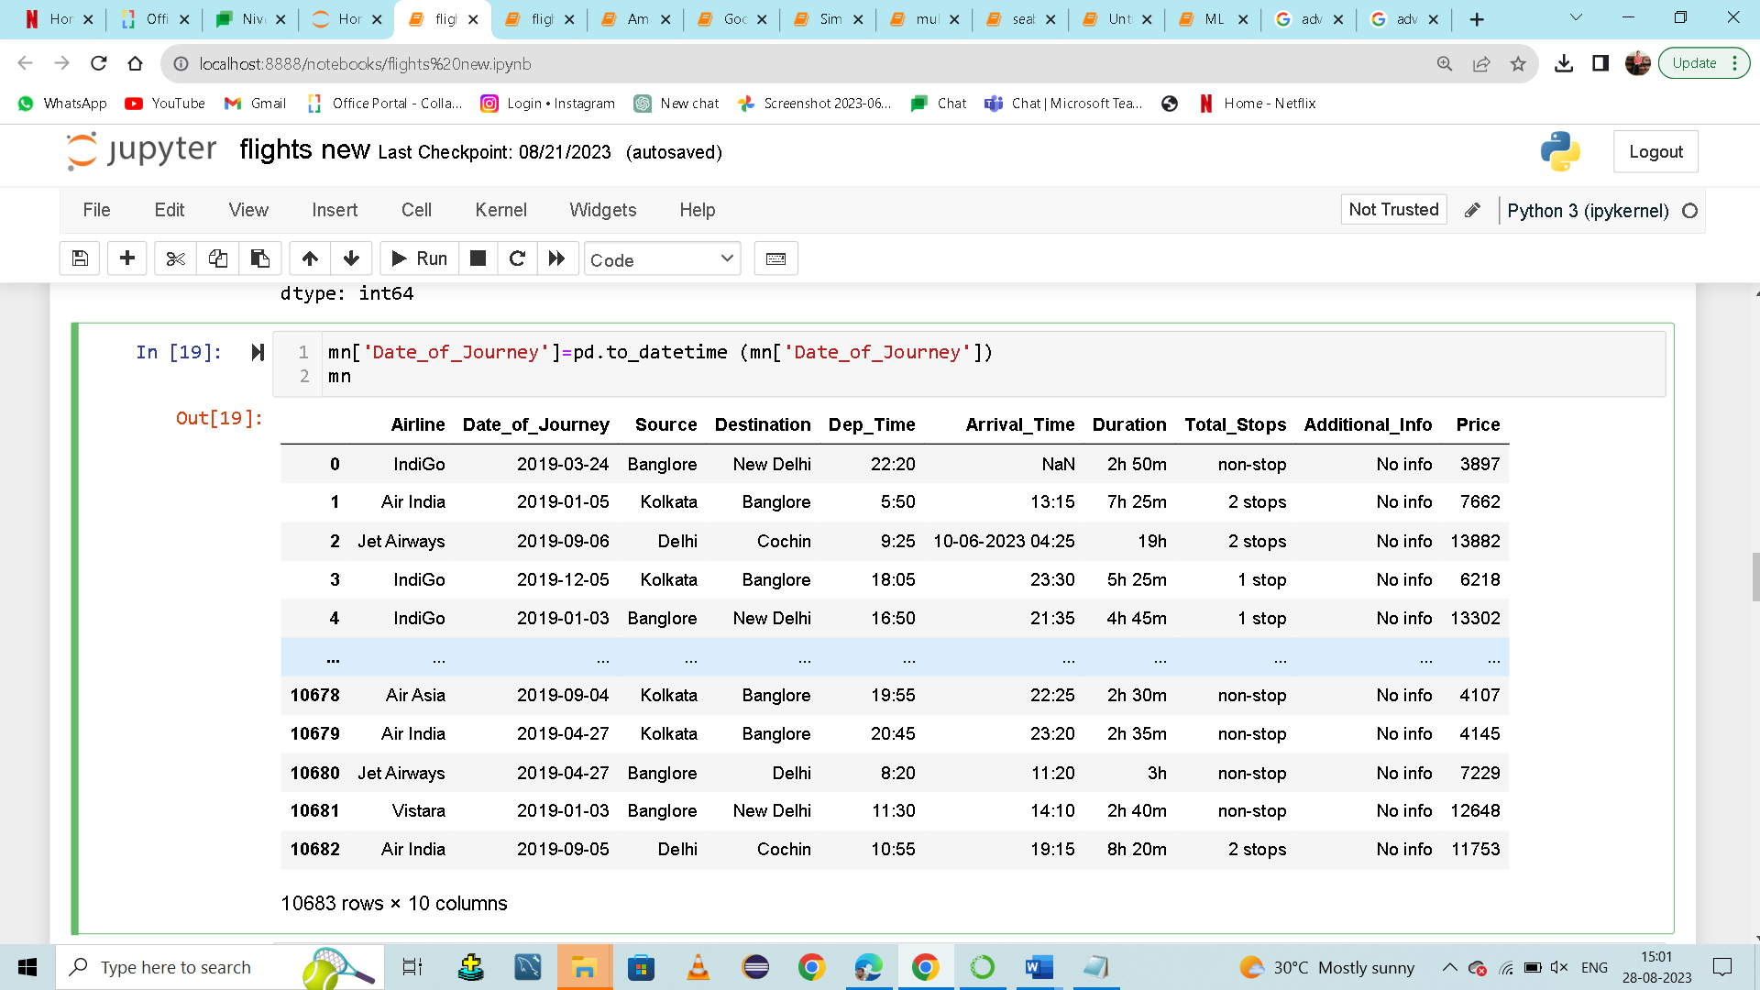

**Step:11**:

Checking the unique values to found out null values. fletching column name called Arrival_Time in double code.unique() function finds the unique elements of an array and returns these unique elements as a sorted array.

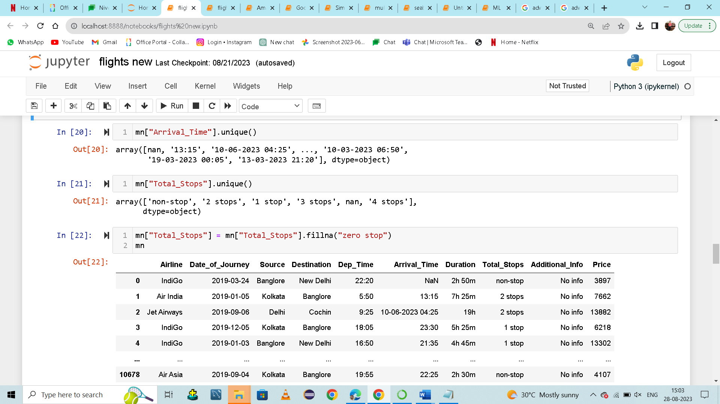

**Step:12**:

Checking the unique values to found out null values. . fletching column name called Total_Stops in double code.unique() function finds the unique elements of an array and returns these unique elements as a sorted array.



**Step:13**:

Converting the columns into data time.mn is a predefined variable.then in square bracket we are fletching column name called 'Date_of_Journey' in double code.by using datetime function we are converting 'Date_of_Journey' in the form of datetime.

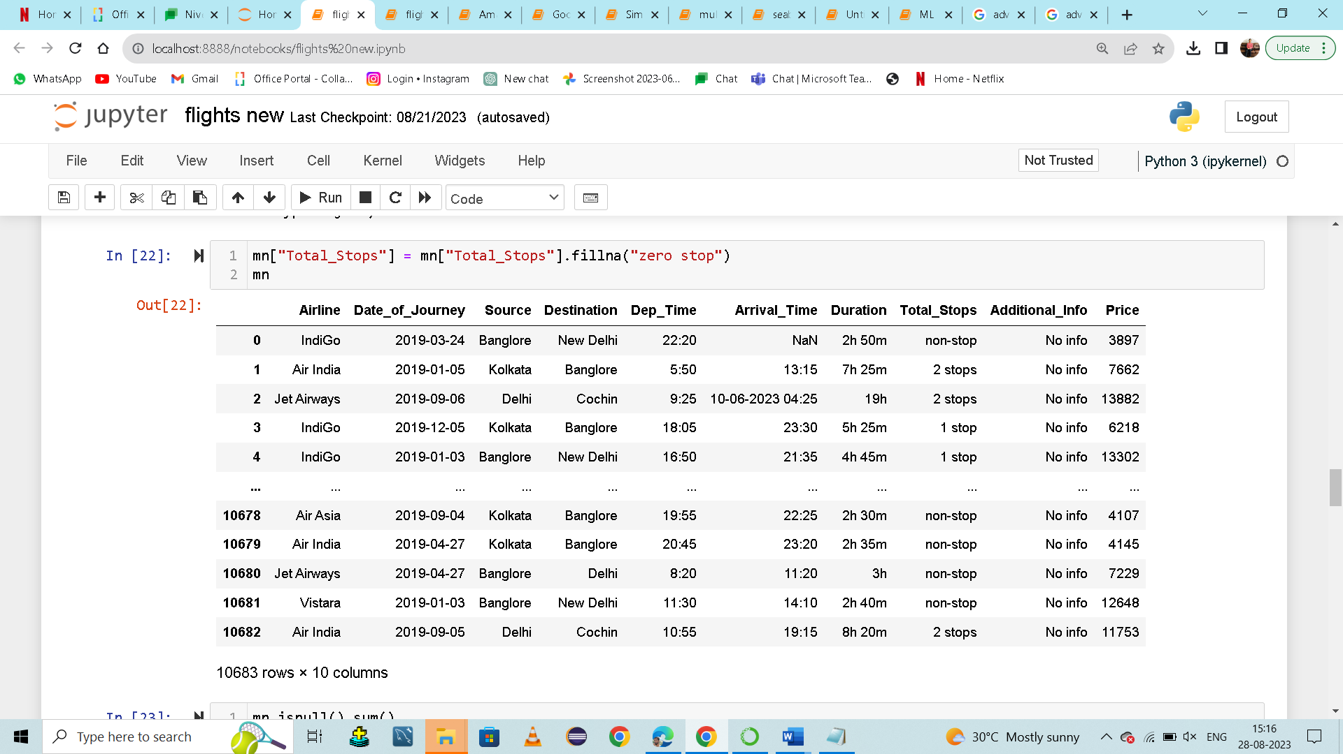

**Step:13**:

mn is predefined variable. Isnull().sum() is used to returns the number of missing values in the dataset.Rechecking the null value in sum method.

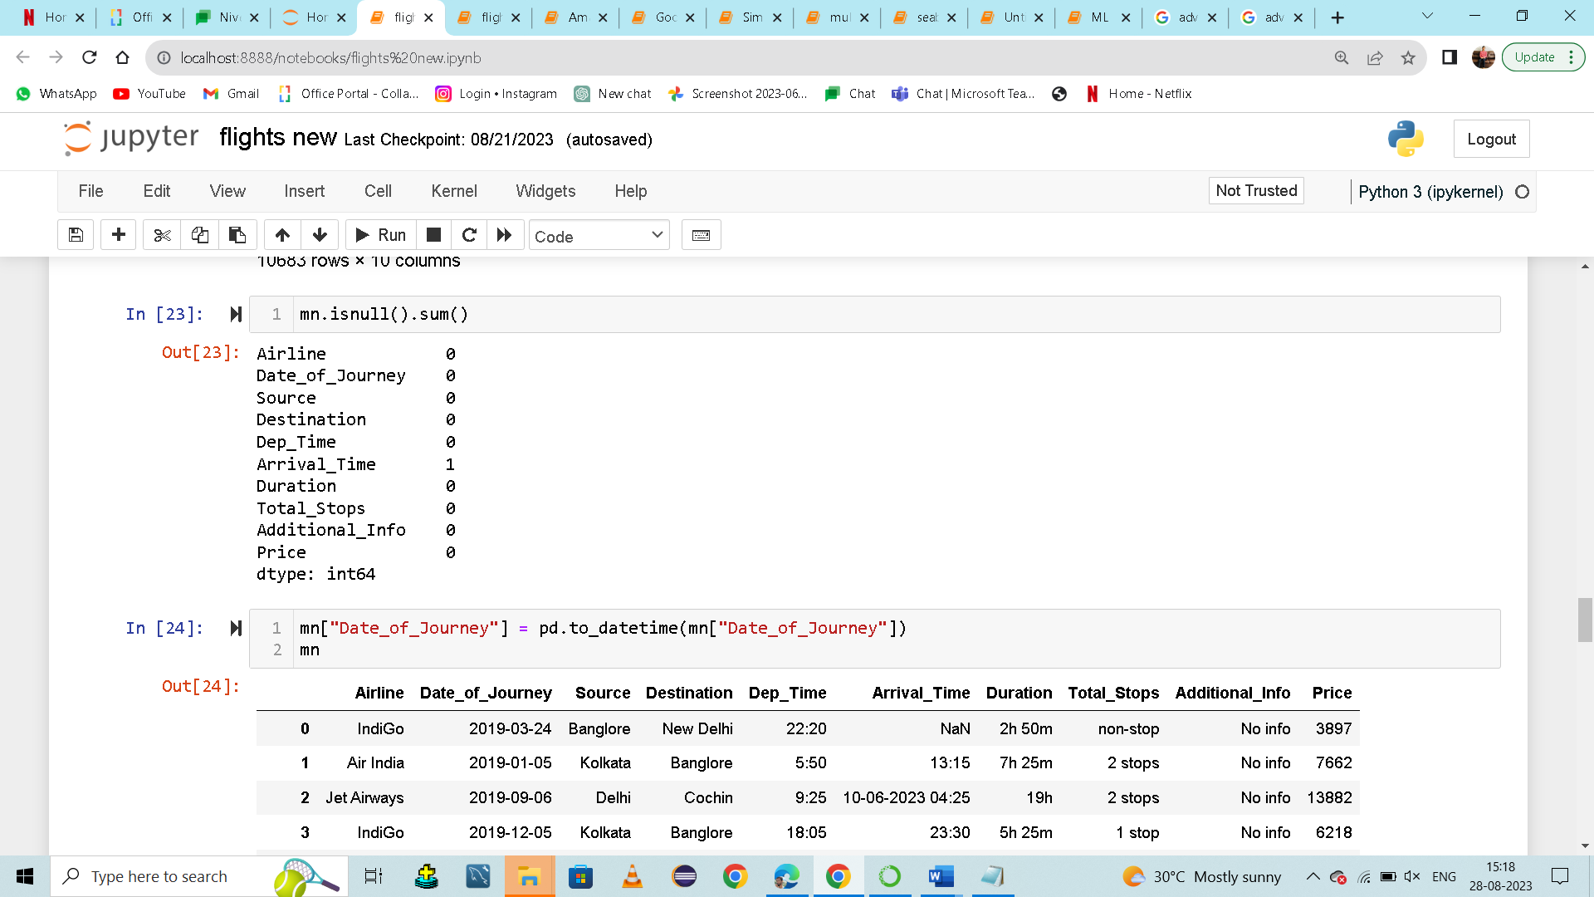

**Step:14**:

Converting the columns into data time.mn is a predefined variable.then in square bracket we are fletching column name called 'Date_of_Journey' in double code.by using datetime function we are converting 'Date_of_Journey' in the form of datetime.

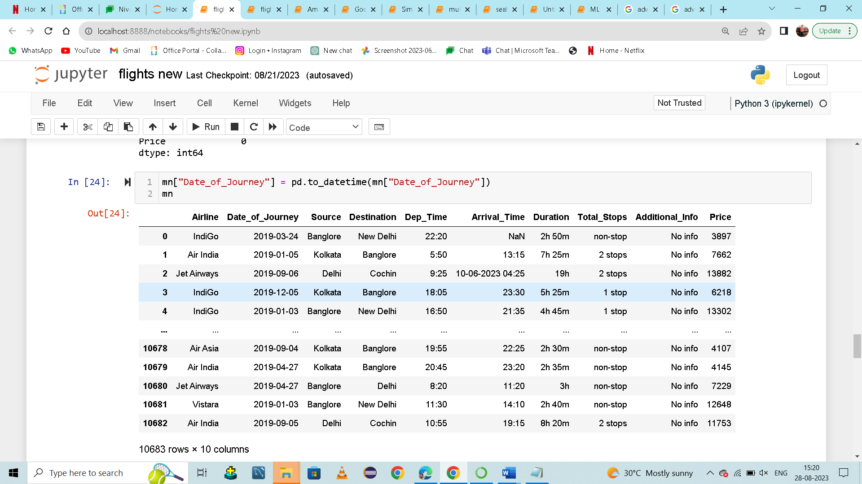**Step:15**:

Converting the columns into data time.mn is a predefined variable.then in square bracket we are fletching column name called 'Dep_Time’ in double code.by using datetime function we are converting 'Dep_Time’ in the form of datetime.

